Procedural Motions

POINTS & INCIDENTAL MOTIONS
The below motions take precedence over any pending questions or motions out of which they arise. Some motions are only incidental under certain circumstances. Most of these motions are not debatable and can be used at any point during the program weekend:

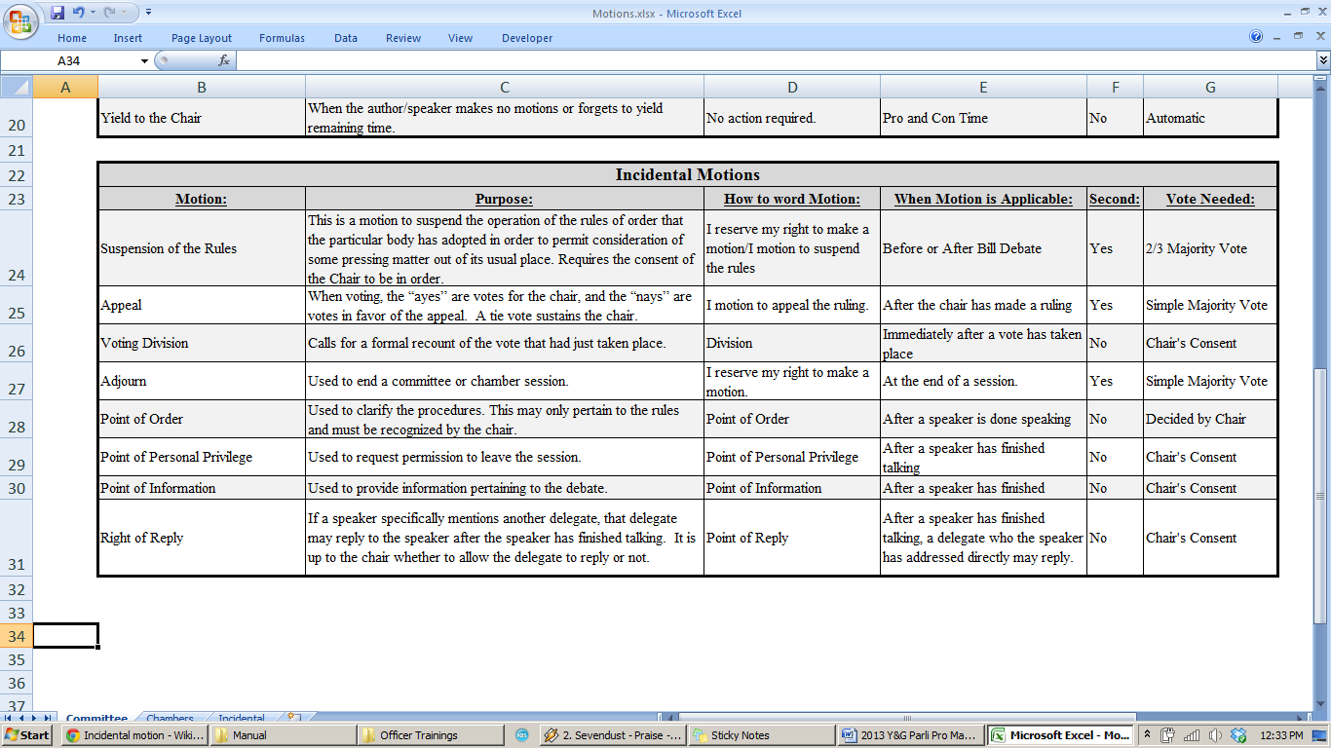

COMMITTEE & CHAMBER MOTIONS
These motions can be utilized during Committee and Chamber Sessions in the following circumstances:
